

# SELF ASSESSMENT TASK I

|  |  |
| --- | --- |
| **Name: Section:** | **FIRST SEMESTER: Q3-CHAPTER 1** |
| **Lesson/Topic:** Introduction to Personal Development | **Subject:** Personal Development |
| **Objectives:**   * Develop self-awareness and understand more about themselves and others. * Explain in his or her own words what personal development is and the psychological basis of personal development. | |

* **JOHARI WINDOW**

In the Johari’s Window, all of the students in the section will participate. The goal is to increase self-awareness and enhance communication within the group. The students will fill in the quadrants based on their self-perception, qualities, traits, and experiences in the "Open" quadrant and their hidden aspects in the "Hidden" quadrant. They can ask others in the group to provide input on their qualities, strengths, weaknesses, and blind spots.

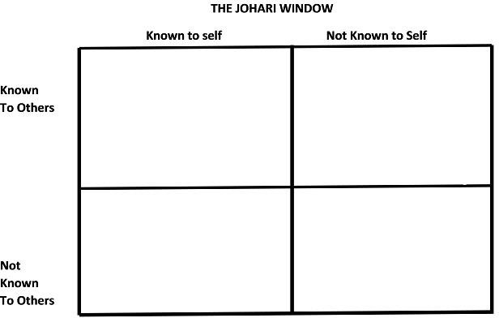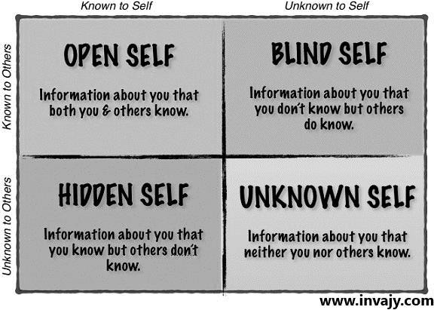

Unknown Self

Hidden Self

Blind Self

Open Self

### Mirror of Yourself (Journal Writing)



* **Performance Task:**

The students will reflect individually on their experience with the Johari Window exercise provided by set of guided questions and thinking about the feedback they received, the insights they gained, and any emotions or thoughts that arose during the process.



## Questions:

* What did you learn about yourself through this exercise?
* Were there any surprises or unexpected feedback?
* How did it feel to receive feedback from others?
* Did the exercise change your perception of yourself?
* Were there any challenges or difficulties you encountered?
* What actions or changes do you plan to make based on this experience?



|  |  |
| --- | --- |
| **Name: Section:** | **FIRST SEMESTER: Q3-CHAPTER 2** |
| **Lesson/Topic:** Knowing Oneself | **Subject:** Personal Development |
| **Objectives:**   * Recognize that knowing oneself can make a person accept his or her strengths and limitations, and deal with others better. * Develop self-worth/self-esteem by appreciating their own personality. | |

# THE LIFE WHEEL

Instructions: Grade yourself on each of the 7 Aspects from 1 to 5 according to the following scale:

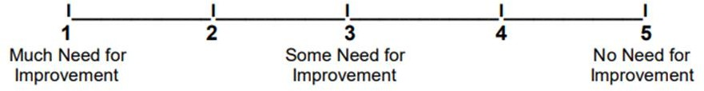

Physiological Psychological Social

Cognitive Spiritual

The table below will help you to evaluate the five aspects of your individuality. On the section “Present state” please write how will you assess your current situation on that specific aspect while on the section “Goals” please write what do you desire in accomplishing in that particular aspect. You may enumerate your answers.

|  |  |  |
| --- | --- | --- |
| **ASPECTS** | **PRESENT STATE** | **GOALS** |
| PHYSIOLOGICAL |  |  |
| PSYCHOLOGICAL |  |  |
| SOCIAL |  |  |
| COGNITIVE |  |  |
| SPIRITUAL |  |  |



## Performance Task:

### Mirror of Yourself (Journal Writing)

The students will reflect individually on their experience with the Life Wheel exercise provided by set of guided questions and thinking about the feedback they received, the insights they gained, and any emotions or thoughts that arose during the process.

## Questions:

1. What are my long-term goals and aspirations? Where do I see myself in the future, and what steps can I take to move closer to those goals?
2. What are my fears and limiting beliefs? What holds me back from fully expressing myself or pursuing my dreams?
3. What are my preferred learning and communication styles? How do I best absorb information, and how do I effectively express myself to others?
4. What have been the most significant lessons I've learned from past experiences or challenges? How have they shaped me into the person I am today?
5. What are the relationships that nourish and support me? Who are the people in my life who bring out the best in me and inspire me to grow?



|  |  |
| --- | --- |
| **Name: Section:** | **FIRST SEMESTER: Q3-CHAPTER 3** |
| **Lesson/Topic:** Developing the Whole Person | **Subject:** Personal Development |
| **Objectives:**   * Discuss the relationship among physiological, cognitive, psychological, spiritual, and social development to understand one’s thoughts, feelings, and behavior. * Evaluate one’s thoughts, feelings, and behavior and show the connection between thoughts, feelings, and behavior in actual life situations. | |

# MIND AND BODY

Have you noticed any changes in your bodies and the way you think and behave, your attitude? *(You can enumerate your answer)*

|  |  |  |  |
| --- | --- | --- | --- |
| WHAT ARE THE CHANGES YOU ARE EXPERIENCING? | | | |
| BODY | WAY, YOU THINK | BEHAVIOR | ATTITUDE  (Towards other people) |
|  |  |  |  |

How do you deal with these changes, who do you talk to, what support do you have, how has it affected your life? *(You can enumerate your answer)*

|  |  |  |
| --- | --- | --- |
| HOW DO YOU DEAL WITH IT? | | |
| TO WHOM YOU TALK TO? | TYPE OF SUPPORT THAT YOU HAVE | HOW I AFFECTED YOU? |
|  |  |  |

**Reflection:** What are the words or phrases which represent aspects about yourself which you like? What are the items which you consider to be weaknesses or areas for improvement? Name some ways in which you can improve the weak areas and further enhance the positive aspects.

# SELF ASSESSMENT TASK I



|  |  |
| --- | --- |
| **Name: Section:** | **FIRST SEMESTER: Q3-CHAPTER 4** |
| **Lesson/Topic:** Development Stages in Middle and Late Adolescence | **Subject:** Personal Development |
| **Objectives:**   * List ways on how to become a responsible adolescent prepared for adult life. * Develop a sense of personal identity, including values, beliefs, and goals. * Engage in self-reflection, evaluate personal strengths and weaknesses, and develop a realistic self-concept. | |

## Build-up Your Knowledge

Explain the following concept below. Write your answer in the line provided.

1. What changes happen during adolescence?
2. Which of these changes are you experiencing now? What changes have you experienced?
3. Which developmental task and skill do you want to develop for yourself? How will you develop them?
4. What other factors, aside from those that were discussed, do you think influence or determine self-identity or self-concept?

## Reflection



|  |  |
| --- | --- |
| **Name: Section:** | **FIRST SEMESTER: Q3-CHAPTER 5** |
| **Lesson/Topic:** The Challenges of Middle and Late Adolescence | **Subject:** Personal Development |
| **Objectives:**   * Discuss that facing challenges during adolescence may help clarify and manage the demands of teen years; * Make a solution that teach assertiveness skills and empower adolescents to say "no" when faced with negative peer pressure. | |

* **Let’s Do This!**

As a teenager who is experiencing challenges in the stages of middle and late adolescence, how will you help your co-teenager to cope up and overcome those challenges? Make an infographic for this and give a short solution about those challenges. Below is the example of an infographic that you may follow. Do this on a bond paper.

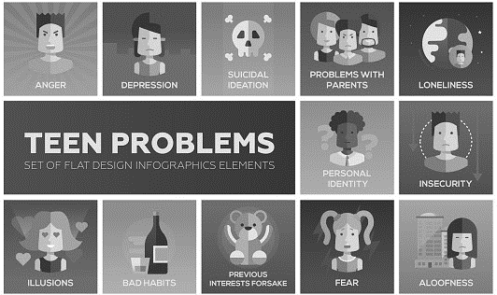

## Time to Reflect

1. What do you think are the common challenges of middle and late adolescence?
2. What are some developmental tasks and skills appropriate for middle and late adolescence?
3. Why is it important to know those challenges as a teenager in the middle and late adolescence?



|  |  |
| --- | --- |
| **Name: Section:** | **FIRST SEMESTER: Q3-CHAPTER 6** |
| **Lesson/Topic:** Coping with Stress in the Middle and Late Adolescence | **Subject:** Personal Development |
| **Objectives:**   * Identify stressors in your life and develop healthy coping mechanisms. * Demonstrate personal ways of coping with stress for healthful living. | |

# STRESS SIGNALS

Instructions: Take a look at the warning signs of stress listed below. Put check and answer the questions below in 3-5 sentences.

|  |  |  |
| --- | --- | --- |
| **PHYSICAL** | **EMOTIONAL** | **BEHAVIORAL** |
| headaches stomach aches dizziness  back pain neck stiffness ulcer  sores on mouth jaw pains weight loss weight gain  twitches (eyelids, face) weakness  nausea indigestion  excessive sleeping overeating  loss of appetite  inability to sleep skin problems constant fatigue  cold hands or feet excessive sweating  chest pains  High blood pressure Rapid or Difficulty in  breathing | Mood Changes  Lack of concentration  Nightmares  Panic attacks  Anxiety  Anger  Irritability  Crying  Thoughts of suicide  Depression  Confusion  Feeling helpless  Restlessness  Racing thoughts  Aggressiveness | smoking nail biting tapping pulling hair  grinding hair use of alcohol use of medication compulsive dieting  hair chewing nervous laughter pacing  lateness  putting things off not caring about  physical appearance compulsive overeating |

1. **Knowing Yourself More:** Write your answers at the back sheet of this paper.
   1. How do you know that you are stressed?
   2. How are your stress signals different for different types of stressors?
   3. What are some ways that you usually remove or reduce the stress that cause you physical, emotional or behavioral difficulties?



|  |  |
| --- | --- |
| **Name: Section:** | **FIRST SEMESTER: Q3-CHAPTER 7** |
| **Lesson/Topic:** The Power of the Mind: The Whole Brain Theory | **Subject:** Personal Development |
| **Objectives:**   * Discuss that understanding the left and right brain may help in improving one’s learning. * Explore two types of mind mapping techniques suited to right brain- or left brain- dominant thinking styles. * Create a plan to improve learning using left and right brain through mind mapping techniques. | |

# MIND MAP

Create a mind map and show in a detailed approach the concept of “Whole Brain Theory”. You may also include other angles such as activities/ characteristics involved in relevance with the quadrants of the brain.

## Processing Questions

1. What is the importance of the whole brain concept?
2. How does the whole brain theory affect the learning process of a person?
3. In what kinds of situations can whole brain thinking be used?



|  |  |
| --- | --- |
| **Name: Section:** | **FIRST SEMESTER: Q3-CHAPTER 8** |
| **Lesson/Topic:** Mental Health and Well-being in Middle and Late Adolescence | **Subject:** Personal Development |
| **Objectives:**   * Identify negative thought patterns and beliefs that contribute to your mental health and well-being challenges. * Foster a growth mindset, self-awareness, and overall well-being. | |

# BINGO WELLNESS CHALLENGE

Use a highlighter and shade the following activity that you have done for the past one week.

Be honest on your answers.

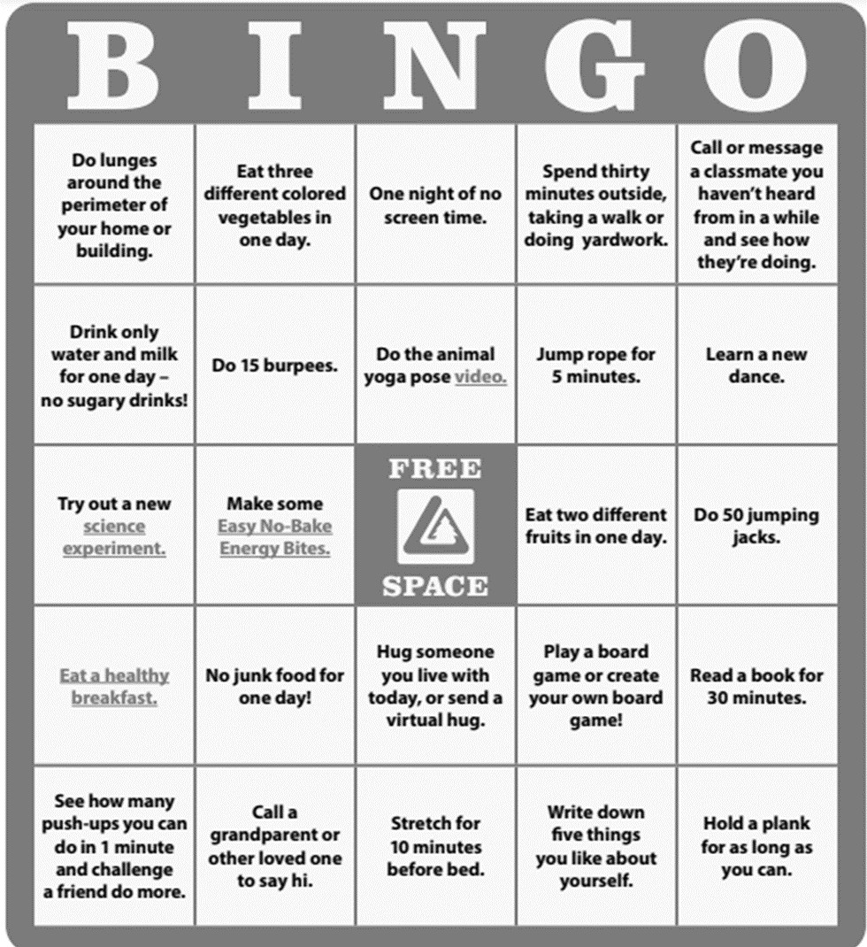

The students will reflect individually on their experience with the “Bingo Wellness



* ***Mirror of Yourself (Journal Writing)***

Challenge” exercise provided by set of guided questions and thinking about the feedback they received, the insights they gained, and any emotions or thoughts that arose during the process.



## Questions:

* What have you learned about yourself during this challenge?
* What new insights or perspectives have you gained throughout this challenge?
* What strategies have you utilized to bounce back from setbacks and navigate changes?





|  |  |
| --- | --- |
| **Name: Section:** | **FIRST SEMESTER: Q4-CHAPTER 9** |
| **Lesson/Topic:** Emotional Intelligence | **Subject:** Personal Development |
| **Objectives:**   * Explore one’s positive and negative emotions and how one expresses or hides them * Understand other people’s emotions and how to manage them | |

# EMOTIONAL INTELLIGENCE ASSESSMENT

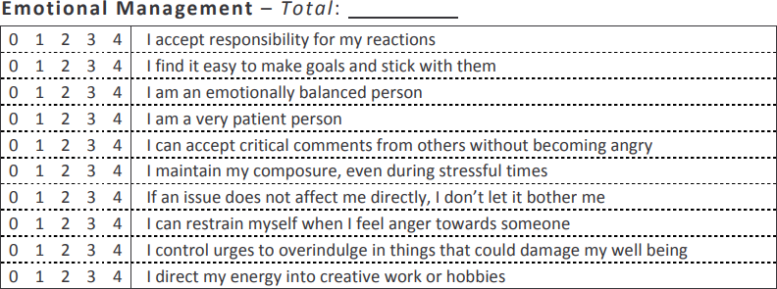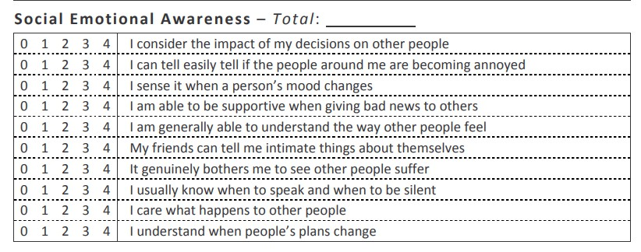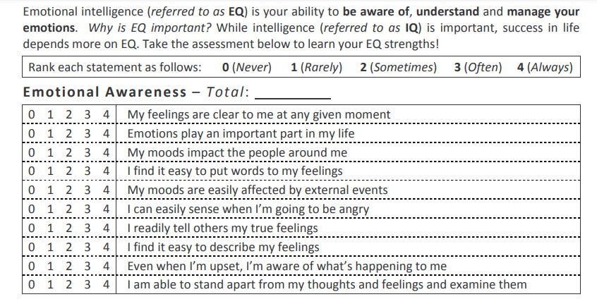





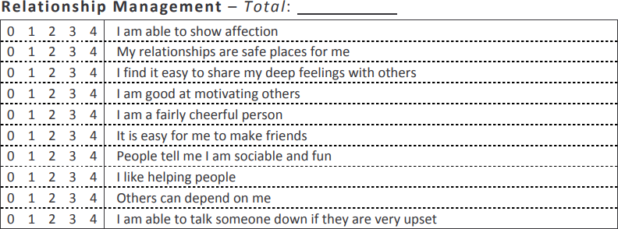

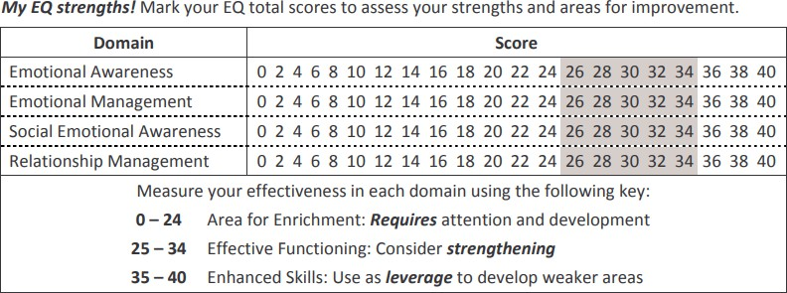

**Using your EQ Strength-** *For your strongest EQ Domain, give an example of how you demonstrate your strength in your daily life:*

**Effects of your EQ Strength-** *For your weakest EQ Domain, give an example of how this affects you and others in your daily life:*

**Improving your EQ strength-** *For your weakest EQ Domain, what steps can you take to strengthen yourself in this area? How will this benefit you in your daily life?*

### Reference: https://neotecouncil.org/wp-content/uploads/2012/04/EmotionalIntelligence-Self- Assessment.pdf



|  |  |
| --- | --- |
| **Name: Section:** | **FIRST SEMESTER: Q4-CHAPTER 10** |
| **Lesson/Topic: PERSONAL RELATIONSHIP** | **Subject:** Personal Development |
| **Objectives:**   * Identify ways to become responsible in a relationship. * Distinguish relationship boundaries between healthy and not. * Reflect on their relationship towards people around them | |

I. Use a colored pen to show your perspective regarding personal relationship. Please following legend given allotted for color red, yellow and green.

|  |  |  |  |  |
| --- | --- | --- | --- | --- |
| **COLOR LEGEND** | | | | |
| RED | | Stop! These are bad sign of relationship. | | |
| YELLOW | | Caution! These are warning signs of relationship. | | |
| GREEN | | Go! These are good signs in a friendship. | | |
|  | 1. You are afraid of your friend’s temper. | |  | 9. You say that you agree with your friends, even though you really don’t.  You are afraid they won’t be your friend anymore, if you disagree. |
|  | 2. You enjoy being with this person but you also enjoy spending time with other friends. | |  | 10. You rarely get to plan what the two of you will do together. |
|  | 3. Your friend pressures you to do things you do not want to do. | |  | 11. Your friend threatens to hurt you. |
|  | 4. Your friend tells you not hangout with certain people. | |  | 12. You are nervous that if you tell  your friend something personal, he/she will tell to other people in school. |
|  | 5. You usually feel happy when you are with this  person. | |  | 13. Your friend is happy when good things happen to you, and celebrates your successes. |
|  | 6. Your friend talks to you about his/her feelings. | |  | 14. Your friends sometimes make fun of you. |
|  | 7. Your friend criticizes you or people you cared about. | |  | 15. Your friends respects your feelings and your opinions. |
|  | 8. Your friend bullies and makes fun of other people at school. | |  | |

Let us now try to find out your concept of ‘love’ through this Love Quiz. Read each statement below carefully and write A if you agree with the statement, and DA if you disagree with it. Write your answers on the space provided before each number.



* **Love Quiz**



1. “Love at first sight” occurs between some people.

2. It’s easy to distinguish real love from infatuation.

3. People who sincerely love each other will not fight and argue.

4. I believe that fate selects one particular person for each of us to marry, and that it will guide us together.

5. If a man and a woman genuinely love each other, then hardships and troubles will have little or no effect on their relationship.

6. It’s better to marry the wrong person than to remain single and lonely throughout life.

7. I believe that it is not sinful to have sexual intercourse before marriage if the couple has a meaningful relationship.

8. If a couple is truly in love, that condition is permanent and will last a lifetime.

9. Short courtships, two months or less, are the best.

10. Teenagers are more capable of genuine love than are older people.

## Mirror of Yourself

Let us now find out your personal relationship with different people around you. On this part, you will be going to discuss or share what is your personal relationship with the following:

* 1. Parents -
  2. Friends -
  3. Relatives -
  4. Opposite Sex -



|  |  |
| --- | --- |
| **Name: Section:** | **FIRST SEMESTER: Q4-CHAPTER 11** |
| **Lesson/Topic: Social Relationships in Middle and Late Adolescence** | **Subject:** Personal Development |
| **Objectives:**   * Distinguish the different roles of individuals in society and how they can affect people through their leadership or followership. * Express his or her feelings on the expectations of the significant people around him or her (parents, siblings, friends, teachers, community leaders). | |

## Building Connection

Let us know the people around you. How close are you to them? How is your social communication or relationship to them? Through the given instructions below, answer it honestly by knowing the people around you, then answer the following questions. You may follow the given sample. This will be done during your virtual class.

## Instruction:

The Relationship Target has four (4) circles. The inner one is “You”. The other three (3) levels include:

1. People you are closest to and talk with often, like your family members.
2. People you are kind of close to but don’t see as often, like friends.
3. 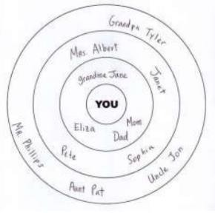People you are not close to and don’t see often, like the store clerk.

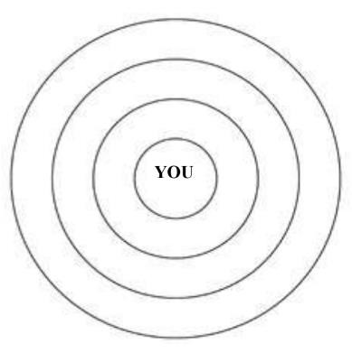

1. How do you think are you influenced by these people?
2. Who among the people you’ve written affects you the most? Why do you think this happened?
3. Do you think in some way you influence them? Why or why not?



|  |  |
| --- | --- |
| **Name: Section:** | **FIRST SEMESTER: Q4-CHAPTER 12** |
| **Lesson/Topic: Understanding Conflict** | **Subject:** Personal Development |
| **Objectives:**   * Understand the nature of conflict and how interpersonal relationships are affected by it. * Appreciate that conflict is a fact of life and a key ingredient in human interaction. | |

**Describe the conflict:**

**The Choices I Have:**

**The Pros:**

**The Cons:**

**Final Decision:**

## Essay



Now that you have learned the nature of conflict and how you can resolve it using different conflict management styles, it is now time to assess how you can portray it in your daily life. Read each statement carefully and write your answers on the lines provided below during your virtual class.

* 1. Explain how conflict can be good or bad.
  2. What are the usual responses to conflict?
  3. How can you turn conflict into a positive experience?
  4. Analyze a personal conflict that you recently went through and trace the cycle of conflict that transpired.
  5. In your school or at home, what typical types of conflict have you observed?
  6. Name at least three kinds of conflict you observed and identify how these could Have been handled by the persons involved to resolve it.

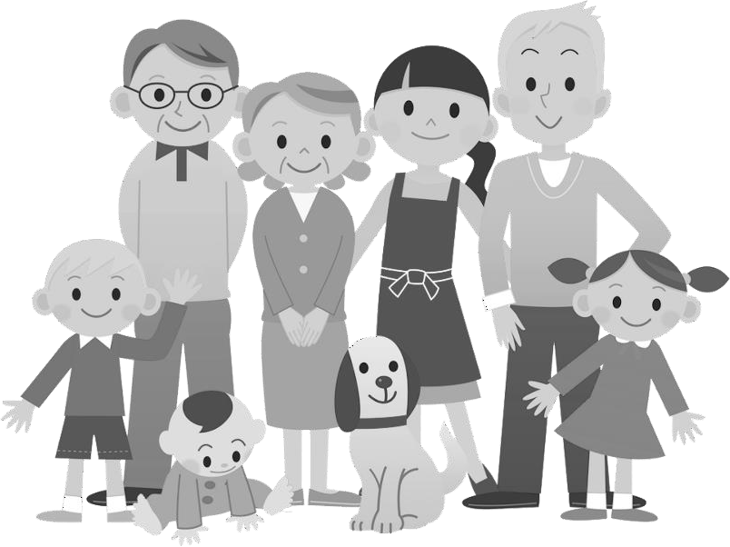

|  |  |
| --- | --- |
| **Name: Section:** | **FIRST SEMESTER: Q4-CHAPTER 13** |
| **Lesson/Topic: Family Structures and Legacies** | **Subject:** Personal Development |
| **Objectives:**   * Appraise one’s family structure and the type of care he or she gives and receives, which may help in understanding himself or herself better * Prepare a plan on how to make the family members firmer and gentler with each other. | |

## Understanding My Own Family Structure

In this activity, you will need a family picture. Paste it on the space below, then label their names with the use of lines and boxes. If you do not have a recent family picture, you can cut out pictures from the magazines and just put name of your family member on each picture. In a short paragraph, describe your family. Elaborate on your family’s social, emotional and spiritual legacies.

**My Family**